Florida Trust Custodian Bank RFP- 2026

Clarifying Questions- Vendor 1

General Questions:
- Why is this RFP being issued? As part of their duties of oversight of the Trust, the Board of Trustees periodically issues RFPs to ensure that pricing and scope of services remain competitive within the marketplace.
- Are there any pain points or challenges that the plans are looking to address? No. All required or requested features are listed in the RFP.
- Please confirm the account types for investor accounts, i.e municipal operational type accounts? Typically investors in the Day to Day Fund utilize it for near-term operational expenses, whereas the Short-Term Bond Fund is used more for capital projects or reserve funds.
- Is there a need for accounts to be linked in any manner? Is there an umbrella account, with underlying sub accounts? Due to the nature of their operations, many of our clients have multiple accounts within one or both funds. These accounts are often designated for particular projects and must be kept in separate accounts, even if all the money is invested in the same fund. Clients must be able to access multiple accounts from one login, with role-based access limits in place. There is no umbrella account/sub-account structure.
- Are investors currently permitted to open accounts online? Investors are not currently able to open accounts online due to security requirements. Solutions or options for this can be addressed in Section 2.1 of the RFP.
- Are any types of fees assessed to accounts, for example, wire fees? Currently no fees are assessed to the individual accounts. Clients may be charged wire fees by their bank, but not by the Florida Trust.
- Are securities valued at amortized cost? For the financial statements, the Day to Day Fund securities are valued at amortized cost and in the Short-Term Bond Fund, securities are valued at market value. For fund reporting, both funds are reported at market value.
- How often is income distributed to investors? In the Day to Day Fund, dividends are distributed monthly. In the Short-Term Bond Fund, the return is provided in the form of share value, with Net Asset Value updated daily.
- If a security is sold or any other principal gain/loss is generated how is that processed in the fund? Any change in value of the fund is reflected in the fund’s overall value and distributed based on shares owned.
- What reporting, regulatory or otherwise, will be required from the service provider? Required reporting is as described in the RFP in Section 12. Reporting for compliance with the Ratings Agency and Board of Trustees requirements are performed by the Administrator utilizing the information from the Custodian bank.

Data Request:
- Please provide account volume by type (global vs. domestic separately managed). All volume is domestically managed. Portfolio details are included in the excel file provided with the RFP. Additional historical reports are available on our website, Reports – Florida Local Government Investment Trust
- Please provide number of incoming and outgoing wires, annually.
Day to Day Fund Transactions
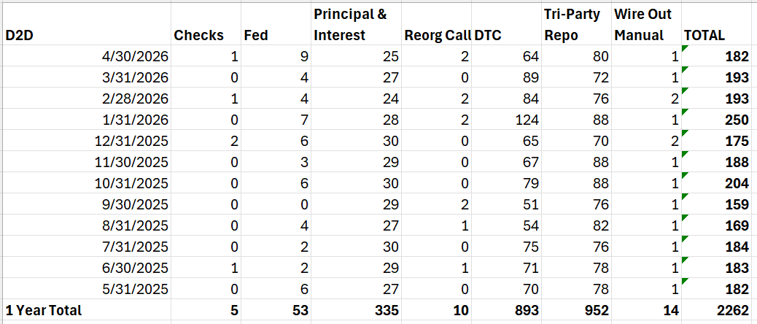

Short-Term Bond Fund Transactions:
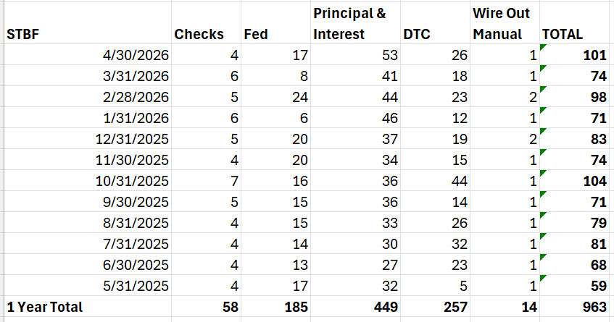

- Is there any derivatives exposure? If so, please provide the type of position, how many open positions and the typical annual trade activity by position type. No. Derivates are not permitted in the funds.
- Please confirm if there is any interest in pricing information for our Treasury Money Market Fund. No. According to Section 6.03 Prohibited Transactions of the Declaration of Trust: “With respect to transactions involving Trust Property, the Custodian shall act strictly as agent for the Trust. The Trustees shall not purchase Permitted Investments from the Custodian or sell Permitted Investments to the Custodian.”

